SOFTWARE REQUIREMENTS SPECIFICATION FOR EXPENSE TRACKER SYSTEM 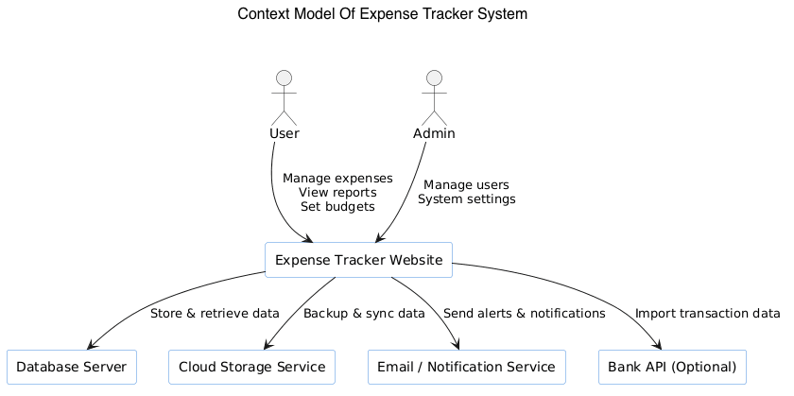
The context model shows the Expense Tracker Website as the central system interacting with external entities. Users interact with the system to manage expenses, budgets, and reports, while the Admin manages users and system settings. The system communicates with the Database Server to store and retrieve data, Cloud Storage for backup and synchronization, Email/Notification Service for alerts, and an optional Bank API for importing transaction data.
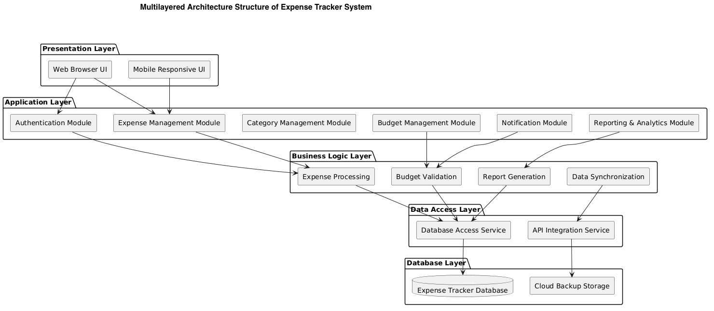
The multilayered architecture diagram divides the Expense Tracker Website into different layers for better organization and maintainability.

Presentation Layer: Provides the user interface through web browsers and mobile-responsive pages.

Application Layer:
Handles main system modules such as authentication, expense management, budgeting, reporting, and notifications.

Business Logic Layer: Processes expenses, validates budgets, generates reports, and manages synchronization logic.
Data Access Layer: Connects the system with databases and external APIs.

Database Layer: Stores expense data and cloud backup information. This layered structure improves scalability, security, maintainability, and system performance.

Table Of Contents

1. Introduction 1
1.1 Purpose 1
1.2 Document Conventions 1
1.3 Intended Audience and Reading Suggestions 1
1.4 Product Scope 1
1.5 References 1
2. Overall Description 2
2.1 Product Perspective 2
2.2 Product Functions 2
2.3 User Classes and Characteristics 2
2.4 Operating Environment 2
2.5 Design and Implementation Constraints 2
2.6 User Documentation 2
2.7 Assumptions and Dependencies 3
3. External Interface Requirements 3
3.1 User Interfaces 3
3.2 Hardware Interfaces 3
3.3 Software Interfaces 3
3.4 Communications Interfaces 3
4. System Features 4
4.1 System Feature 1 4
4.2 System Feature 2 (and so on) 4
5. Other Nonfunctional Requirements 4
5.1 Performance Requirements 4
5.2 Safety Requirements 5
5.3 Security Requirements 5
5.4 Software Quality Attributes 5
5.5 Business Rules 5
6. Other Requirements 5
Appendix A: Glossary 5
Appendix B: Analysis Models 5
Appendix C: To Be Determined List 6

1. Introduction

1.1 Purpose
The purpose of this document is to describe the requirements of the Expense Tracker Website. The system helps users record, manage, and analyze their daily expenses easily and efficiently.

1.2 Document Conventions
- Headings are numbered in order
- “Shall” means a mandatory requirement
- “Should” means a recommended requirement
- “May” means an optional feature

1.3 Intended Audience and Reading Suggestions
This document is prepared for:
- Developers
- Project Managers
- Stakeholders
- QA/Test Engineers
Readers should first read the Introduction and Overall Description sections before reading the detailed system features.

1.4 Product Scope
The Expense Tracker Website allows users to:
- Record daily expenses
- Categorize expenses
- View reports and summaries
- Set budgets and financial goals
- Track spending habits

1.5 References
- IEEE 830 SRS Standard
- Software Engineering Best Practices
- Financial Tracking Application Guidelines

2. Overall Description

2.1 Product Perspective
The Expense Tracker Website is a web-based system used to manage daily income and expenses online. Users can access the system through a web browser from any device with internet access.

2.2 Product Functions
The website can:
- Add expenses
- Edit expenses
- Delete expenses
- Categorize expenses
- Track budgets
- Generate daily, weekly, and monthly reports
- Backup and sync data
- Show spending alerts

2.3 User Classes and Characteristics

General Users
- Manage personal expenses online
- Have basic knowledge of using websites

Advanced Users
- Need detailed reports and analytics
- Use budgeting and tracking features regularly

Admin
- Manages website settings
- Maintains user data and system security

2.4 Operating Environment

Web Browsers
- Google Chrome
- Microsoft Edge
- Safari
- Mozilla Firefox

Server
- Cloud-based web server
- Internet connection required

2.5 Design and Implementation Constraints
- Must support secure login
- Must protect user data and privacy
- Website should be responsive on desktop and mobile devices
- Some features may require internet connection

2.6 User Documentation
The website provides:
- User guide
- FAQ section
- Help and tutorial pages

2.7 Assumptions and Dependencies
- Users have internet access
- Browser and server work properly
- External APIs (if used) remain available
- Users have devices with enough storage and updated browsers

3. External Interface Requirements

3.1 User Interfaces
The website includes:
- Dashboard with expense summaries and charts
- Expense entry form
- Category management page
- Reports and analytics page
- Budget tracking page
- Login and registration pages

3.2 Hardware Interfaces
The system can be accessed using:
- Computer or laptop
- Smartphone or tablet
- Internet connection
Optional features:
- Fingerprint authentication
- Face recognition

3.3 Software Interfaces
The system may connect with:
- SQL or NoSQL database
- Bank APIs (optional)
- Cloud storage services
- Email notification service

3.4 Communication Interfaces
The system uses:
- HTTPS for secure communication
- REST API for frontend and backend communication
- Internet connection for syncing and backup features

4. System Features

4.1 Expense Management
- Users can add expenses
- Users can edit expenses
- Users can delete expenses
- Each expense includes:
  - Amount
  - Category
  - Date
  - Notes

4.2 Category Management
- Users can create custom categories
- The system provides predefined categories
- Users can edit or delete categories

4.3 Reporting and Analytics
- Users can view expense reports and summaries
- The system generates charts and analytics
- Reports can be filtered by:
  - Date
  - Category
  - Amount

4.4 Budget Management
- Users can set monthly budgets
- Users can set category-based budgets
- The system shows alerts when budget limits are exceeded

4.5 Data Synchronization
- Users can sync data across multiple devices
- The system supports backup and restore functions
- Data is updated through cloud synchronization

5. Other Nonfunctional Requirements

5.1 Performance Requirements
- The website should load within 2 seconds
- The system should support at least 10,000 transactions per user
- Reports should generate quickly and smoothly

5.2 Safety Requirements
- The system should prevent data loss during crashes
- Automatic backups should be performed regularly
- User data should be recoverable after failures

5.3 Security Requirements
- Users must log in securely using email/password or OAuth
- Data should be encrypted during transmission and storage
- The system should use secure session management
- Unauthorized access must be prevented

5.4 Software Quality Attributes

Usability
- Simple and easy-to-use interface

Reliability
- Minimal downtime and stable performance

Scalability
- Ability to support more users and data in the future

Maintainability
- Modular and well-structured code for easy updates

5.5 Business Rules
- Every expense must include a valid amount
- Dates must be entered in a correct format
- Budget alerts are triggered when spending exceeds the limit
- Users cannot save incomplete expense records

6. Other Requirements
- Multi-language support (optional)
- Dark mode user interface (optional)
- Export data in CSV or PDF format
- Responsive design for desktop and mobile devices
- Notification and alert support

Appendix A: Glossary

Expense
Money spent by the user.

Category
A type or classification of expense such as food, travel, shopping, or bills.

Budget
A spending limit set by the user for a specific period or category.

Appendix B: Analysis Models

B.1 Use Case Diagram
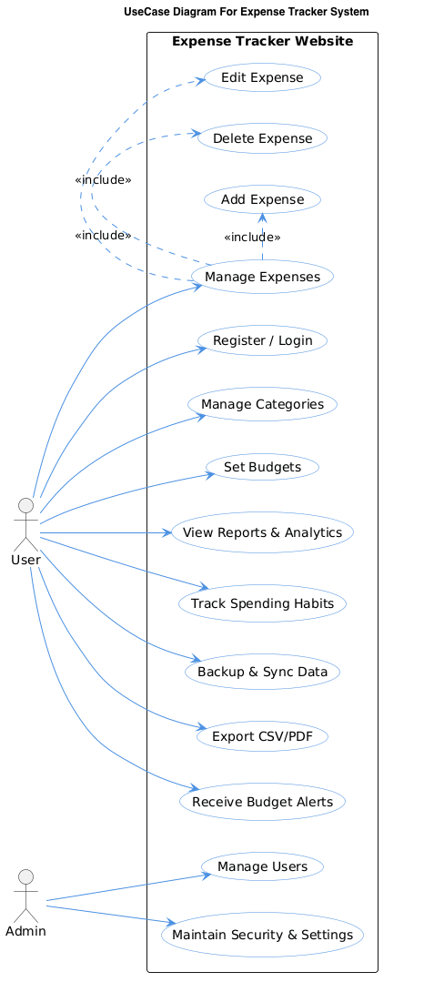

B.2 Detailed Use Case Description

The Use Case Diagram of the Expense Tracker Website shows how users and admins interact with the system. The main actor is the User, who can register/login, manage expenses, create categories, set budgets, view reports and analytics, track spending habits, sync and backup data, export reports, and receive budget alerts. Expense management includes adding, editing, and deleting expenses. The Admin actor manages users and maintains system security and settings. The diagram presents the main functionalities of the website in a simple and organized way, showing the relationship between users and system features.

B.3 Sequence Diagram

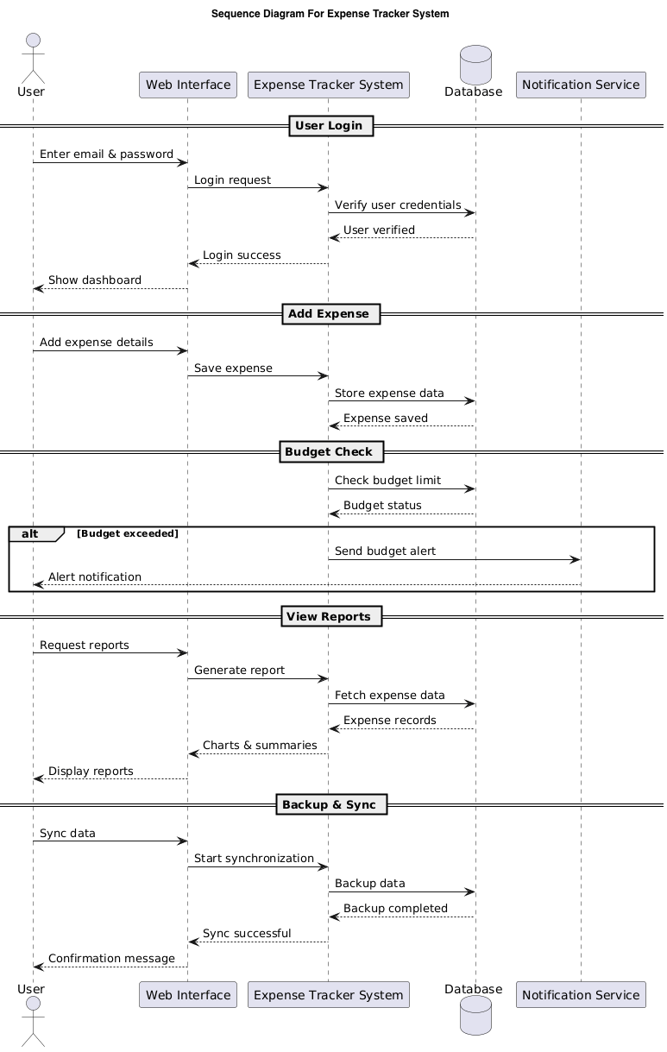
The sequence diagram shows how the user interacts with the Expense Tracker Website step by step. First, the user logs into the system, and the system verifies the credentials using the database. The user can then add expenses, which are stored in the database. The system checks the budget limit and sends alerts if the budget is exceeded. Users can also request reports, where the system retrieves expense data and displays charts and summaries. Finally, the system supports backup and synchronization of data across devices.

Main Components
- User – person using the system
- Web Browser / Frontend – user interface of the website
- API Gateway – handles requests between frontend and backend
- Authenticate Service – manages login and JWT authentication
- Expense Service – handles expense operations
- Analytics Service – generates reports and summaries
- Database – stores all data
- Notification Service – sends alerts and notifications

Overall Purpose
The diagram explains how the Expense Tracker system:
- Authenticates users securely using JWT,
- Manages expenses,
- Generates analytics and reports,
- Monitors budgets,
- Sends alerts when limits are exceeded.

mockup
https://expensetracker259.netlify.app/

